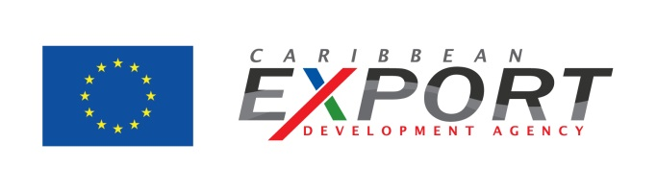
Planning Export Finance
Planning your export finance broadly revolves around two issues – (a) the costs involved in setting up and running an export operation and (b) the approach needed to manage payment risk.
(a) Export running costs
The actual cost of an overseas’ operation will, naturally, depend on the market itself, the route to market and the scope of your operation. Costs can generally be divided between those that are fixed, such as flights, rent, transport, exhibition space, printing and website costs, and those which are more variable, such as sales personnel and currency fluctuations. A budgeting process should aim to be as exhaustive as possible in assessing these, e.g.: sales person on the road; translation services; five trips to market etc.
However, until you become familiar with the market, a simple rule of thumb in budgeting is to allow for twice as much as anticipated. Once familiarity with local costs develops, the process becomes similar to financing any project and to working out whether the Return on Investment (ROI) makes it worthwhile.
(b) Managing payment
Weak cash flow is the single greatest challenge to businesses in a recession and those entering the export market may expose themselves to a higher risk of delayed repayment and bad debt.
Extending credit to the wrong customers could jeopardise your financial security and calling in debts in a foreign jurisdiction may be far from simple. In addition to credit, exporters also need to be wary of suffering losses through deterioration in foreign exchange rates.
Credit management
The first thing any company needs to do to minimise these risks is get their own house in order. Your credit terms and contractual conditions are the primary tools to rely on for good cash flow management. You may need to review your internal procedures to ensure that issues are flagged early on and that you can ‘turn the heat up’ before they become critical.
Export credit insurance
Export credit insurance is an option for large contracts. The cost typically ranges from 0.2-0.5% of turnover although premiums have increased over the last few years. Risk factors that affect the premium include the political and economic climate of the country you are trading into; the enforceability of legal judgments there; the financial standing of your customer and your terms of payment.

Letter of credit
Next to advance payment, the safest payment option is a letter of credit, where the bank pays the exporter and then collects the payment from the buyer's bank at a later stage. These are covered by international law rather than the law of the destination country. Terms and conditions are generally very strict and it is important to have a role in compiling them to ensure they can be followed and payment will not be delayed.
An alternative is for the exporter to obtain payment (or a commitment to pay) through the buyer’s bank, with your bank acting as intermediary.
Tips
- Conduct research on the banking services available in your country.
- Consult with your financial adviser and your bank. Do you have the finances to back your export plans and are there any funding risks that you should be aware of? Are the credit lines you need available?
- Have contracts drawn up for each market you are exporting to and always obtain legal advice from specialists in that market before signing.
- Proactively manage your collection process to minimise delays and disputes and to quickly identify bad debt risk.
- Carry out background credit checks, preferably before the salesperson meets the buyer. An export insurer should be able to advise you on this.
- If you can’t get insurance and feel the payment terms are insecure, you have three options: ask for cash up front, restructure the deal or simply walk away.
- If you cannot secure the full payment up front, it is reasonable to request a certain amount in advance, until the relationship develops.
- Consider offering your customers incentives such as early payment discounts.
- If you offer incentives to your sales team, consider paying them when the cash is collected rather than when the sale is made. This brings a further element of due diligence into the selling process.
- When negotiating international contracts, exporters should consider including provisions for arbitration and for specifying which jurisdiction any potential conflicts are to be addressed in.
Day-to-day expenses are generally not significant. The cost of establishing in a new region is where the big financial sting lies, particularly for smaller companies. Sales people or “feet on the street” are the single biggest outlay.

